# Schaltnetze

## A1 MULTIPLEXER

z = ( a ∧ b ) ∨ (¬c ∧ b)

|  |  |  |  |
| --- | --- | --- | --- |
| a | b | c | z |
| 1 | 0 | 0 | 0 |
| 1 | 0 | 1 | 1 |
| 1 | 1 | 0 | 0 |
| 1 | 1 | 1 | 1 |
| 0 | 0 | 0 | 0 |
| 0 | 0 | 1 | 0 |
| 0 | 1 | 0 | 1 |
| 0 | 1 | 1 | 0 |

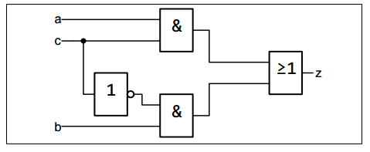

## A2 De Morgan

z = a ∨ b

y = ¬ (¬a ∧ ¬b)

|  |  |  |  |
| --- | --- | --- | --- |
| a | b | z | y |
| 0 | 0 | 0 | 0 |
| 0 | 1 | 1 | 1 |
| 1 | 0 | 1 | 1 |
| 1 | 1 | 1 | 1 |

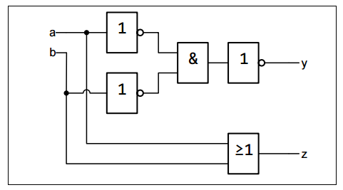

## A3 XOR

z = (a ∧ ¬b) ∧ (¬a ∧ b)

|  |  |  |
| --- | --- | --- |
| a | b | z |
| 0 | 0 | 0 |
| 0 | 1 | 1 |
| 1 | 0 | 1 |
| 1 | 1 | 0 |

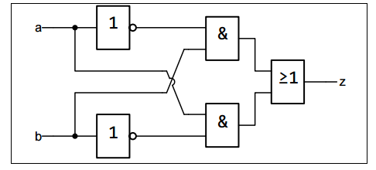

## A4 ADRESSDECODIERER

z = a ∧ b

y = ¬a ∧ b

x = a ∧ ¬b

w = ¬a ∧ ¬b

|  |  |  |  |  |  |
| --- | --- | --- | --- | --- | --- |
| b | a | z | y | x | w |
| 0 | 0 | 0 | 0 | 0 | 1 |
| 0 | 1 | 0 | 0 | 1 | 0 |
| 1 | 0 | 0 | 1 | 0 | 0 |
| 1 | 1 | 1 | 0 | 0 | 1 |

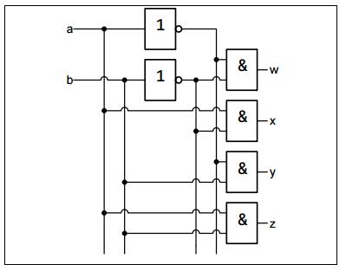

## A5 1-BIT-KOMPARATOR

a ∧ b a ∧ ¬b

z = (a ∧ ¬b)

y = ¬ ((a ∧ ¬b) ∧ (¬a ∧ b))

x = (¬a ∧ b)

|  |  |  |  |  |
| --- | --- | --- | --- | --- |
| b | a | z | y | x |
| 0 | 0 | 0 | 1 | 0 |
| 0 | 1 | 1 | 0 | 0 |
| 1 | 0 | 0 | 0 | 1 |
| 1 | 1 | 0 | 1 | 0 |

